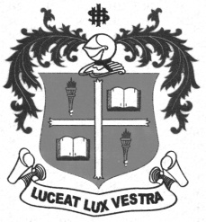
LOYOLA COLLEGE (AUTONOMOUS), CHENNAI – 600 034
B.A. DEGREE EXAMINATION – ENGLISH LITERATURE
FIFTH SEMESTER – APRIL 2012

EL 5404 - DYNAMICS OF ORAL COMMUNICATION
( 2 Hours only)

Date : 30-04-2012 Dept. No. Max. : 50 Marks
Time : 1:00 – 3:00

Answer any TEN of the following in about 150 words each: (10x5=50)

- What are the strategies and techniques that are involved in oral communication?
- Mention the basic elements of communication and the process of sending and receiving of messages.
- Explicate the purpose and the outcome of the Interpersonal communication.
- Write a short note on one-way communication with a relevant example.
- Highlight the significance and role of active listening in group discussion.
- Point out the uses of dyadic communication.
- Give an account on the essential techniques to be adopted in order to improve the presentation skills of a performer.
- Enumerate the essential characteristics to be accomplished and executed for a successful performance in job interviews.
- Explain the importance of non-verbal gestures and its salient features to gain the attention of the audience.
- Elucidate the skills and the duties of the discussion leaders in small group discussion.
- Define the following terms:
- Interpersonal communication
- Metacommunication
- Group worthiness
- Cohesiveness
- Consensus

- “Facebook world contributes peril and depression”. Make your appeals and arguments on this topic for discussion.
- Draft a speech on the topic, “The transitions required in the system of education in India”.

***********

